Technical Notes on Poetic Mode
Rhythm
So far, we have:
The metre which is the number of feet in a line, and the foot which are strings of stressed and unstressed syllables.
These create timing, like a baseline heartbeat for the poem. It is the expected rhythm of the verse.
Number of feet must be neither too long which feels like dragging on too much or too short which just feel like random spikes instead of a proper line carrying meaning.
The foot are repeats which create certainty and little breaks by varying some feet helps break expectations to concentrate attention on a line. It can be a gradual or sudden.

Examples:
|..| in a single verse is one meter or monometric verse
|..||..||..||..||..| is a pentameter or each verse has 5 feet

In a stanza, we can have different meters if we want to
|..||..||..||..||..||..| Hexameter
|..||..||..||..||..| Pentameter
|..||..||..||..||..| Pentameter
|..||..||..||..||..||..| Hexameter

But it is important to keep any pattern consistent, else it becomes nonsense and the reader loses track; have some compassion for the reader
A bad example:
|..||..||..||..||..||..| Hexameter verse
|..||..||..||..||..| Pentameter verse
|..||..| dimeter verse
|..||..||..| trimeter verse

This is nonsense.

It is good to keep an expected rhythm for a stanza and play with slight deviations in a meaningful way.
Example: I want to portray something light and jumpy then suddenly punchy then light and jumpy again
I will use a hexameter for the diffused part, and a pentameter for the slight excitement and a dimeter for sudden punch.
I will do so in 3 stanzas

|..||..||..||..||..||..| Hexameter
|..||..||..||..||..| Pentameter
|..||..||..||..||..| Pentameter
|..||..||..||..||..||..| Hexameter

|..||..| dimeter
|..||..| dimeter

|..||..||..||..||..||..| Hexameter
|..||..||..||..||..| Pentameter
|..||..||..||..||..| Pentameter
|..||..||..||..||..||..| Hexameter

It is good to keep stanza element number a bit consistent like 4 verses per stanzas or even less; but some decrease or increase can concentrate or diffuse tension to maintain attention of the reader.
It is the same as keeping paragraph length more or less consistent, as in prose, no extreme rigidity.

Da-Dum
The content of each foot consists of stressed and unstressed syllables; it has nothing to do with rhyme for technical writing but helps keep the tempo of the meter through word pressure variations. We can have disyllabic feet with two syllables per feet, and similarly, trisyllable, and tetrasyllable.
The most common is the iamb, a disyllabic foot consisting of a stressed syllable (◡) followed by an unstressed one (-)
|◡ -|
For a verse of 5 lines of iambs, we have:
|◡ -||◡ -||◡ -||◡ -||◡ -| which is the iambic pentameter
Similarly,
|- ◡ ◡| is the dactyl
|- ◡ ◡||- ◡ ◡||- ◡ ◡||- ◡ ◡||- ◡ ◡||- ◡ ◡| is the dactylic hexameter

Iambic pentameter is: “Da-Dum-Da-Dum-Da-Dum-Da-Dum Da-Dum”
We can add an inversion if we want: Dum-Da or |- ◡| is the trochee
Da-Dum-Da-Dum Dum-Da Da-Dum-Da-Dum
This adds a bit of difference to lines of a stanza in iambic pentameter

Sometimes it is natural within a line to have a break between words without necessarily changing lines. This is the Caesura (/)
Take classical examples of the opening lines of The Iliad and The Aeneid
They are a single line, and the silence forms part of that line

The Iliad
Sing Goddess/ The anger of Peleus’ son, Achilles

The Aeneid
I sing of arms and the man/ who first from the shores of Troy

Sometimes, one line can runover to the next, this is called enjambement

I am afraid for you
are losing yourself to darkness

Rhyme
It is a pleasant connection between two words that has an appreciable psychological effect on people.
Two words rhyme if their final stressed vowel and all their following sounds are identical.
Two poetic lines rhyme if their final strong positions are filled with rhyming word.

Types of Rhyme
Perfect Rhyme are classified per the location of the final stressed syllable
Single or Masculine: Stress is on the final syllables of the words; Rhyme, Sublime [Ultimate]
Double or Feminine: Stress in on the second from last syllables of the words; Picky, Tricky [Penultimate]
Dactylic: Stress is on the third from last syllables; Amorous, Glamorous [Antepenultimate]

General Rhymes are the common applications and concern the manner and degree of phonetic similarity between words.

- Syllabic rhymes have last syllables of words sounding similar without necessarily containing a stressed vowel, cleaver, silver, or pitter, patter.
- Imperfect or near rhyme between a stressed and unstressed syllable, wing, caring
- Weak rhyme between a set of two or more unstressed syllable, hammer, carpenter
- Semi rhyme with an extra syllable in one word, bend, ending
- Forced or oblique, rhyme with imperfect match in sound, (green, fiend), or (one, thumb)
- Assonance: Matching vowels, shake, hate
- Consonance: Matching consonants, rabies, robbers
- Half-rhyme: Matching final consonants, hand, lend
- Pararhyme: all consonants match, tick, tock
- Alliteration: matching initial consonants, ship, short

Identical Rhymes

These are considered cheaper in English but valuable in other languages
Perfect rhyming has 2 conditions:
- The stressed vowel in both words sound the same
- The words after the stressed vowel sound the same
Example: Rhyme and Sublime
- Identical rhymes have the consonants before the stressed vowel sound similar which makes the choice of words for rhyme creation look trivial.
Examples are bare, bear, or flower, flour, or gun, begun

Perfect rhymes do not impose these strict conditions and allow variations in the onset which is desirable

Mind Rhyme
These are lines where an expected rhyming word is replaced by something else
Example:
Raa Raa REE!
Kick 'em in the knee!
Raa Raa RASS!
Kick 'em in the other knee!

Now they're going to bed
And my stomach is sick
And it's all in my head
But she's touching his chest now [dick]

Classification by Position in Verse
Tail rhyme, the most common is the rhymes of the final syllables of a verse.

Internal rhyme occurs when a word inside the line rhymes with the word at the end or from another line.

Off-center rhymes are internal rhymes in unexpected places.

Broken rhyme occurs when we divide a word at a line break to make that word rhyme with another line.

Rhyme Scheme
Suppose we have a grouping of lines/verse called stanza. We want to make their tail rhyme.
If we have 4 lines in a stanza, ABAB notation signifies the first line rhymes with the third and the second with the fourth.
If we have 2 2-lines stanza, AB AB is same here.
XAXA denotes absence of rhyme in first and third line and second line rhyming with third

We can have AABB, ABAB, ABBA, AAAA. Each of these can be employed in a poem for the elemental stanzas. However, care must be taken to “mellow” their entry upon changing, or justified the intended impulse in the poem. A sudden shock stanza would be AAAA, engulfement could be ABBA, journey could be ABAB, and like fatal sword strikes could be AABB

Ballad Stanza
It is a common stanza template with 4 lines (quatrain) with rhyming scheme ABCB, with the first and third line in tetrameter and the second and fourth line in trimeter. All feet are in iambic.
There are 8 syllables in line 1 and 3, (2 from iamb x 4 feet from tetrameter)
There are 6 syllables in line 2 and 4, (2 from iamb x 3 feet from trimeter)

Syllables
Vowels are sound produced with an open vocal tract. They form the nucleus of syllables.
Consonants are produced by closure or obstruction in the vocal tract. They surround vowels in syllables and live in the onset and the coda.
Vowels usually have the highest sonority peak in a syllable.

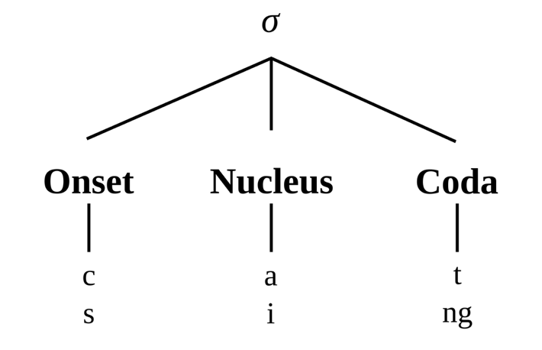

For rhyme, the nucleus of syllables must match, for perfect rhyme, the nucleus and coda must match.

Stressed and Unstressed Syllables
This is hard to formalize and explain without going into complex networks of linguistics details.
It is a stressed syllable, the one which is phonetically amplified and made prominent relative to others, in a word.
It is best to learn to identify them and build a rhythm accoddingly when choosing words.

Quick Tips
In a word, suppose dishonour, the syllable count can be taken to be the vowel count. However, each vowel must carry a phonetic weight. Stressed and unstressed syllables can be taken as which phonetic vowel the emphasis is on. Which one when speaking you will speak the loudest.
Example: dishonour Vowels: i, o, o, u
i, o, ou: the u barely gets its own sound and it gets absorbed in the third syllable
i: not the emphasis as we do not say DIShonour
ou: not the emphasis as we do not say dishonOUR
o: the emphasis, we say disHONour

Monosyllaibic words have stress assignment by grammatical weight. The stress of the syllable is context dependent. Speak it.
Examples of monosyllabic words are: this, flame
You cannot decompose “this” into syllables th- i -s
Nor “flame: into fl- a -me
These are phonetic segments not syllables
A syllable has a structure as defined above.
Onset + Nucleus + Coda
fl + a + me
fl and me wrap around a

A nice way is asking ourselves how many vowel beats do we hear when we say a word at natural speed. “a” counts as one for flame. Consonants do not count.

